**Washington Color Painters**

Washington Color Painters were a group of nonobjective, post-painterly abstractionists working in Washington, D.C., in the late 1960s, who believed that the formal property of colour was fundamental to modern art. In June 1965, the Washington Gallery of Modern Art mounted *Washington Color Painters*, a travelling exhibition showcasing the artwork of Morris Louis, Kenneth Noland, Gene Davis, Thomas Downing, Howard Mehring and Paul Reed. Subsequently the term ‘Washington Color School’ or simply ‘Washington school’ has come to characterise this style of highly chromatic, large-scale painting made by soak-staining or striping pigment onto unprimed canvas. Noland has noted that such a school never existed for the earliest Washingtonian abstractionists such as Louis and himself; rather, the term refers to students of these artists, who coined it in the later 1960s. Other notable artists associated with the movement include Sam Gilliam, Mary Pinchot Meyer and Hilda Thorpe.

In 1953, Louis and Noland visited HELEN FRANKENTHALER’s studio in New York City and saw her iconic *Mountains and Sea* (1952), a monumental painting, made by saturating areas of unprepared canvas with oil paint heavily diluted with turpentine. Upon returning to Washington, Louis and Noland experimented with Frankenthaler’s so-called ‘soak-staining’ technique, working with viscous, fast-drying acrylic paints instead of oils. As a new synthetic pigment, acrylic afforded the artist a full range of brilliant, nearly fluorescent hues, which was unusual for the time. These intense colours and the novel method of painting quickly became a part of the core conversation among Washington artists.

The Washington painters gave viewers little or no context for reference and the subject is the painting itself. Some painters were quite freeform, while others preferred suspended, restrained shapes, stripes or diaphanous layers. These paintings almost all eliminate surface incident, achieving the near elision of pigment with the canvas support. This last point was in concert with the art criticism of CLEMENT GREENBERG, who had recently argued in defense of flatness and opticality as the highest goals of abstract painting in his essay ‘Modernist Painting’ (1961). With their tense interplay between assertive colours and purposeful, tidy, compositions, the Washington school artists seemed to epitomise Greenberg’s latest paradigm. Their articulation of the expressive and formal effects of colour also hearkens back to HENRI MATISSE andthe FAUVES.

The Washingtonian arts community was small in comparison to New York, and there were only a handful of cultural institutions supporting this new work. The Jefferson Place Gallery (now defunct) was a notable outlet for the Washington school. Most of the movement’s practitioners knew one another as colleagues and students at American University, Catholic University, and the Corcoran College of Art and Design.

**References and further reading**

Cohen, J. and Tebow, E., et al. (2013) *Washington Art Matters: Art Life in the Capital, 1940-1990.* Washington: Washington Arts Museum.

De Lima-Greene, A. and Wilkin, K., et al. (2005) *Kenneth Noland: the nature of colour.* Houston: The Museum of Fine Arts.

Greenberg, C. (1964) *Post Painterly Abstraction*. Los Angeles: Los Angeles County Museum of Art.

Morris, K. and Cavagnaro, A., eds. (2006) *Morris Louis Now: An American Master Revisited*. Atlanta: The High Museum of Art.

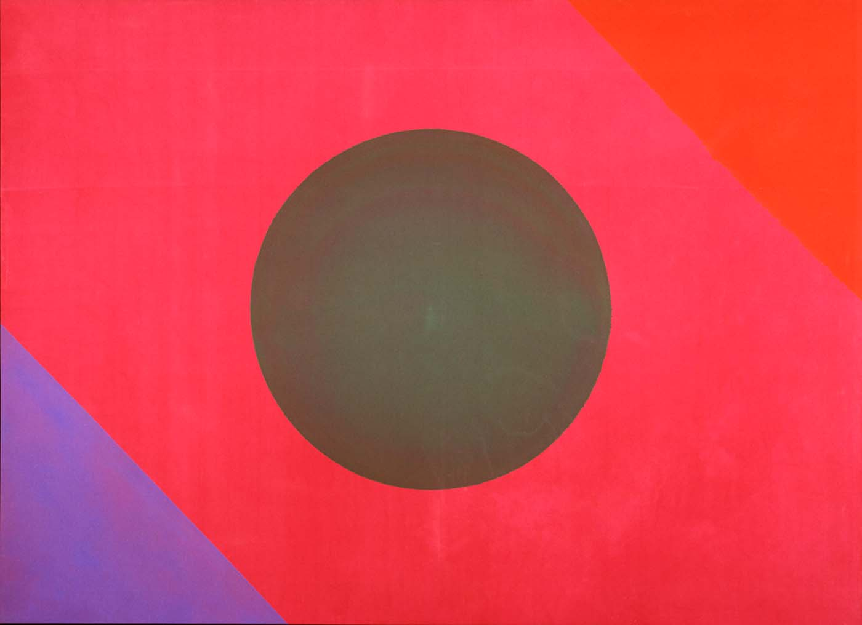

Paul Reed

*#1D*

1965

Acrylic on canvas

172.8 x 237.7 cm

Smithsonian American Art Museum

Washington, DC

<http://americanart.si.edu/images/1993/1993.55_1a.jpg>